Alumni Association
Formation of Mahant Laxmi Narayan Das Alumni Association has done under Banner of Mahant Laxminara Das Mahavidyalaya Gandhi Chowk Raipur Run by Shiksha Pracharak Samiti Raipur (C.G.). Mahant Laxminarayan Das Alumni Association has been constituted on 31st may 2017 under the firms and society registration act 1973 with bearing registration no 36398 dated on 31-05-2017.

Formation of this Alumni Association has done with following objectives:-

- To collect information about old regular student of college and organize a meeting with them.

- To create a communication between old regular student of college for betterment of institution.

- To do work related with the academics of college.

- All other activities and work which can be done for betterment of present studying student of college.

- To take advice and suggestion for innovation and betterment of academic quality of college.

- To provide assistance and guidance to present regular student of college by old regular student (alumni) of college.
- To inform different categories of student about importance and relevance of higher education.

With above objective Mahant Laxminarayan Das Alumni Association is fulfilling their objectives and Responsibilities towards college. In academic session 2022-23 activities has done by alumnus of college like

- Plantation in college so that new entrants can be motivated for green eco-friendly environment and they also aware others towards plantation so that they can do some important and good work for their society in the banner of social responsibility. The Alumni Association organized a tree planting activity at the Sejbahar campus of the newly constructed Mahant Laxminarayan Smriti College building.
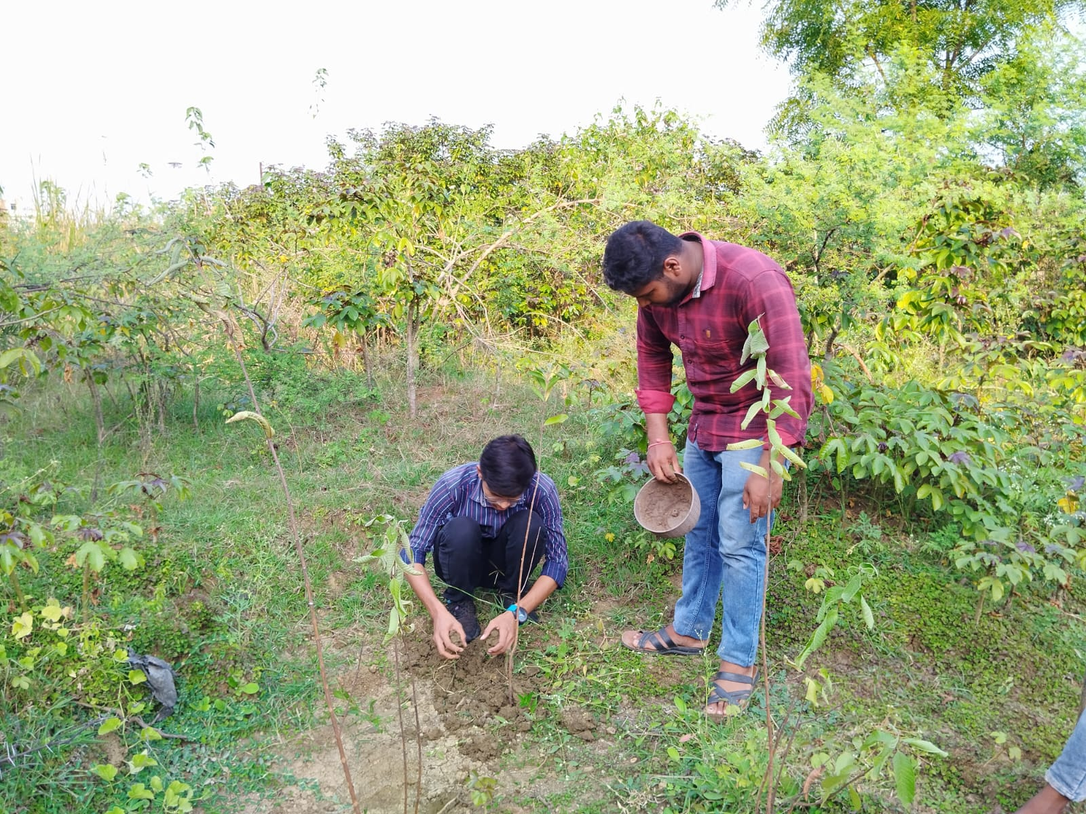

- Ceiling Fans Donation: - In the session 2022-2023, the Alumni Association of Mahant Laxminarayan Das College Raipur has donated 04 ceiling fans for the classrooms of the college. As and when required, the college administration installs the donated fans in the classrooms.
